BUSINESS SUPPORT CONTRACT (BSC)

CLIENT CONTRACT №: [BORROWERCONTRACTNO]
CLIENT TRANSACTION CODE [BORROWERTRANSACTIONCODE]

1 PARTIES
- FACILITATOR OF THIS CONTRACT
- BORROWER ENGAGING UNDER THIS CONTRACT
- LENDER (INVESTOR/SECURITIES DEALER)
- LENDING MANAGER (PROVIDING INDEPENEND ESCROW SERVICES)

This CONTRACT is made on [BORROWERSIGNEDDATE00000000] and entered into by and between:

FACILITATOR

Herein after referred to as Party A, THE FACILITATOR

AND

BORROWER
Company Name: [BORROWERCOMPANYNAME]
Address: [BORROWERCOMPANYCOMPLETEADDRESS]
Reg.-Number: [BORROWERCOMPANYREGNO]
Represented by: [BORROWERFULLNAME]
Designation: [BORROWERDESIGNATION]
Passport: [BORROWERPASSPORTNUMBER]
Mobile Phone: [BORROWERPHONENUMBER]
E-Mail: [BORROWEREMAIL]
Herein after referred to as “Party B” THE BORROWER

2 RECITALS
This Business Support Contract builds the basis of a strictly confidential Private Placement Transaction to be conducted between the parties, and was requested by Party B, the BORROWER.

Whereas, Party A is an international business company for financing and investment and is ready, willing and able to provide Party B with a Bank Instrument (Bank Guarantee [BG] or Standby Letter of Credit [SBLC] issued by a top rated world bank, (fully backed by a Certificate of Debt, in the format of an MTN, a Bond, or Commercial Paper, or a Certificate of Deposit clearly identified by ISIN number), and grants the Borrower an exclusive license to use the Bank Instrument. With the assignment of an exclusive license to use the Bank Instrument, the BORROWER may structure project finance, use it on his commercial balance sheet and for general credit enhancement. The license to use the bank instrument is available to a person, or to corporate entity of the BORROWER, and as specified and agreed in a separate Securities Borrowing and Lending Agreement and the terms of this Business Support Contract (BSC). The ownership will not be transferred under either of these arrangements, but the beneficial use of the Bank Instrument is made available as an enhancement to the BORROWER. The BORROWER is assigned all the rights to use the Instrument accordingly. The Bank Guarantee (BG) or Standby Letter of Credit (SBLC) will be issued from a top rated world bank via SWIFT MT760, with a total face value as agreed for a term of 365 days with the possibility for an extension of up to 5 (five) years in total.
Whereas, Party B is a professional business / company and has the capability, experience and facilities to receive this Bank Instrument (Bank Guarantee [BG] or Standby Letter of Credit [SBLC] and utilize it on the terms as outlined.

Whereas, all Parties are ready, willing and able to combine their business possibilities in a BUSINESS COOPERATION for a mutual benefit.

NOW, THEREFORE, in consideration of the premises, and other good and valuable consideration, the receipt and sufficiency of which are hereby acknowledged by the Parties, it is agreed as follows:

3 GENERAL TERMS

3.01 The following signed Business Support Contract (BSC) is a document that is legal binding and enforceable under international law and ICC rules and regulations including NON-CIRCUMVENTION and NON-DISCLOSURE.

3.02 The Parties warrant each other that all representations are true and reliable and legally capable of entering into this Business Support Contract (BSC), that the signatory has the legal authority to enter into this Contract, and that it shall be bound to the terms of this Business Support Contract (BSC) by the signature of the signatory hereto.

3.03 The Parties warrant each other that any contact and/or business exchanges between the Parties will be treated as strictly confidential and that under no circumstances the Parties will directly or indirectly affect or damage the relation between the Parties and its offered contacts.

3.04 The Parties warrant each other that any Party introduced by the other Parties will be treated with the highest professionalism and respect.

3.05 The Parties warrant each other that its contacts are professionally qualified and all businesses presented will always be in respect of the existing international laws and regulations.

3.06 The Parties warrant each other that extended due diligences have been made by their respective legal advisors prior of engaging in this partnership agreement.

3.07 The Parties warrant each other that any Party to this Business Partnership is not allowed, nor authorized to act on behalf of the other Parties without prior written consent from the other Parties.

4 THE SERVICE

4.01 Party A will deliver a Standby Letter of Credit (SBLC) or a Bank Guarantee (BG) (Appendix A), issued by a top world bank with a total face value as agreed.

4.02 Party B will increase the available capital from Standby Letter of Credit (SBLC) or a Bank Guarantee (BG) for financing projects which already are verified, inspected and approved by involved banks.

4.03 The Parties shall be obliged to fulfil conditions of the present Business Support Contract (BSC) with the appendices thereof with honesty, integrity and good faith.

5 THE FINANCIAL INSTRUMENT

Instrument Type Standby Letter of Credit (SBLC) or Bank Guarantee (BG) SWIFT MT760:
Face Value €10 M. to € 500 M.
Currency: | EURO(€)
Lending / Borrowing Fee: | Euro 10M – 99M Euro 9% of Face Value (total) for a 365 days  Euro 100M – 499M Euro 7% of Face Value (total) for a 365 days  Euro 500M - Euro 5% of Face Value (total) for a 365 days
Commission | 2% (two per cent) or as agreed by the BORROWER
SWIFT MT760 Issuing Bank at Facilitator’s option | HSBC, Deutsche Bank, Standard Chartered Bank, Barclays, UBS, Credit Suisse, Commerzbank, BNP Paribas Bank and JP Morgan Chase or any other international Prime Bank
Validity: | One (1) Year and One (1) Day
Payment: | In up to 180 days upon an acceptable payment via PN(B) , or instantly against delivery of the financial collateral and payment agreed with other payment methods (A), (C) or (D)
Payment Mode Lending Fees: | (A) Conditional Irrevocable Pay Order (ICPO) endorsed by borrower’s bank, (B) Unconditional Promissory Note endorsed by receiving bank, (C) conditional payment SWIFT MT103, (D) Conditional Documentary Credit to be sent by SWIFT MT 700- All payment options have to be acceptable and approved by the collateral lender
Desired Mode of Payment:

6 PROCEDURES

6.01 Application with Bank Confirmation
A qualified borrower submits this Business Support Contract (BSC) and requests to borrow high rated securities to back up the emission of a Bank Guarantee or Standby Letter Of Credit in favour of the borrower, with a term of 365 days, to be sent via SWIFT MT760 as to Appendix 2 to the borrower’s receiving bank.

6.02 Wirth this application, the Borrower provides a written confirmation, Appendix 1, issued by his receiving bank, addressed to the Borrower, evidencing the receiving bank’s consent to receive the bank guarantee instrument, Appendix 2, and the receiving bank’s readiness to issue/endorse one of the 4 designated payment methods to pay for the required lending fees against delivery of the Bank Guarantee or Standby Letter of Credit.

6.03 If such a bank confirmation is provided together with this Business Support Contract application, and a borrower proves his company to be of substance through relevant accounts audited by an internationally recognized audit firm (Top 20 ranked international network of audit, tax, accounting & consulting firms as to MGI Worldwide), the “Reservation and Call Option Fee” can be advanced and is paid by the facilitator for the borrower. This makes this facility an absolutely no front fee transaction for a qualified borrower. The Business Support Contract and a duly executed copy will be transmitted from the Facilitator to the Borrower.

6.04 If at the time of application, such a bank confirmation, and/or such audited accounts are not available, the borrower will receive an invoice for the “Reservation and Call Option Fee” directly from the Facilitator to cover the banking, screen, clearing, settlement and stock market charges of the transaction in the amount of Euro 30,000 (thirty thousand Euros only). If this applies to an applicant, APPEMDIX 7 PROOF OF FUNDS has to be completed for this Business Support Contract to be considered and it is mutually understood, that payment and receipt of the Reservation Fee by the Facilitator automatically triggers acceptance and validation of the Business Support Contract and a duly executed copy will be transmitted from the Facilitator to the Borrower.

6.05 If the Reservation and Call Option Fee is provided by the Borrower, it will be fully credited towards the Borrower's commitment to pay commission to the Facilitator’s intermediary. The Borrower has the right to deduct the amount of the Reservation and Call Option Fee from the commission that will be due to be paid by the Borrower to the Facilitator’s intermediary upon a successful conducted transaction.

6.06 Securities Lending Agreement issued
Within 5 banking days, upon receipt, assessment and acceptance of the transaction, the Global Master Securities Lending & Borrowing Agreement for the transaction will be issued by the investor or securities dealer supporting this transaction and is sent to the borrower for signature. Within 3 banking days the Global Master Security Lending and Borrowing Agreement has to be countersigned by the borrower and returned for further processing.

6.07 Reservation and Call Option Fee is placed to buy securities
Within 5 banking days of payment of the Reservation and Call Option Fee by either the facilitator or the borrower, the lender will place the call option to reserve the securities to back up the transaction and will provide a pro forma invoice with all details of the securities, corporate deed of assignment, Euroclear and Clearstream printout, security card of the stock exchange market where the instrument is quoted, to permit the borrower's bankers to verify the availability of the securities.

6.08 Payment Release against Delivery
Within 20 days (from date of pro forma invoice) the borrower must provide for conditional payment as to Appendix 1 upon which the guarantee instrument (backed up by these securities) is transmitted to borrower’s bank to the designated account of the borrower, by SWIFT MT760 and with this transferring also all the rights to use it. At the same time, the conditioned payment will have to be unblocked and payment released.

6.09 Validity
Fifteen days prior maturity of the bank instrument (as to Appendix 2), the borrower's bank must return the instrument by SWIFT to the lender's bank unencumbered and free of liens and encumbrances, or request an extension for another year on the same terms as stated in this Business Support Contract (BSC) and the Global Master Securities Lending & Borrowing Agreement that builds the basis for the emission of the financial instrument issued for this transaction and under the terms of this Business Support Contract (BSC).

7 GENERAL CONTRACT TERMS AND CONDITIONS
Here are the Rights and Obligations of the Parties as agreed. The following terms and conditions build the legal framework to conduct this transaction and are to be considered an integral part of this Business Support Contract (BSC).

7.01 The Parties act as independent legal entity in fulfilment of all its related rights and obligations.

7.02 The rights and duties of this Business Support Contract (BSC) come into effect by the responsibility of the Parties to fulfil this contract.

7.03 Safeguarding of the rights and obligations has to be followed according to the laws and the principles of international business practices.

7.04 The Parties are committed to contribute and introduce all offered possibilities with respect to mutual success. The best solution in favour of this cooperation has to be accepted.

7.05 All important documents related to this Business Support Contract (BSC) in accordance with applicable law and rules for international financial transfers, especially BASEL II+III, will be transferred bank to bank only and finally deposited in the involved banks.

7.06 All payments concerning this Business Support Contract (BSC) will be carried out via bank to bank SWIFT system and in accordance with applicable laws and rules for international financial transfers, especially BASEL II+III.

7.07 All payments shall be made in EUR (EURO €).

7.08 The Parties are liable only in case of wilful intention and gross negligence. Towards third parties, the Party that has caused the damage or harm should be hold responsible solely. The Party that caused the damage has to keep free the other Parties of any claims.

7.09 The activities of Party A focuses on the
- issuing of the Standby Letter of Credit or Bank Guarantee and
- customary transfer via bank to bank to PARTY B nominated bank
- as well as expert advice and monitoring progress in implementing the mediated transactions.

7.10 The activities of Party B focuses on the
- receiving of the Standby Letter of Credit or Bank Guarantee for the transaction
- increase the capital of Party B from the CASH FUNDS or the CREDIT LINE as agreed
- as well as expert advice and monitoring progress in implementing the mediated transactions.

7.11 IDENTIFICATION OF BUSINESS SUPPORT CONTRACT (BSC).
This Business Support Contract (BSC) shall be identified by the name (the client transaction code):

[BORROWERTRANSACTIONCODE]

which shall be used for the complete duration of the Investment as stipulated hereunder unless altered by mutual agreement of the Parties hereto.

7.12 ELECTION OF REMEDIES
The remedies provided herein are not exclusive of any other lawful remedies which may be available, and a Party´s election of a remedy shall not constitute an exclusive election of remedies.

7.13 ARBITRATION
Any controversy or claim arising out of or in connection with this Business Support Contract (BSC), or any related documentation, or the breach thereof, shall be finally settled under the Rules of Arbitration of the International Chamber of Commerce by one or more arbitrators appointed in accordance with the said rules. The Parties agree that the language of the Arbitration shall be English and the venue of the Arbitration shall be Zurich, Switzerland.

7.14 APPLICABLE LAW AND JURISDICTION
This Business Support Contract (BSC) shall be governed by the laws of the Republic of Ireland. The parties are liable for incomplete or partial performance of their obligations subject matter of this Business Support Contract (BSC) in the framework of law of the Republic of Ireland.

7.15 LANGUAGE OF TEXT
The English language version of this Business Support Contract (BSC) shall govern, although its translations may be used during the negotiations between the Parties. Any difficulties or uncertainties in interpretation arising shall be resolved solely by reference to this text.

7.16 FURTHER ASSURANCE AND COOPERATION
Each Party agrees to execute and deliver to the other Parties such other instruments, documents, and statements, including without limitation, instruments and documents of recordation, assignment, transfer, conveyance, and clarification and take such other action as may be reasonably necessary or convenient in the discretion of the requesting Party to carry out more effectively the purposes of this Business Support Contract (BSC).

7.17 INTERPRETATION AND CONSTRUCTION
The word "or" shall be interpreted to have both its conjunctive and disjunctive meaning whenever possible. The paragraph titles are intended solely for convenience and shall not affect the construction or interpretation of any of the provisions of this Business Support Contract (BSC). No provision of this Business Support Contract (BSC) shall be construed in favour of or against any Party on the ground that such Party, or its counsel, drafted the provision. The language used herein, unless defined specifically, shall be construed according to its reasonable and customary meaning in the English language. Terms of art used in this Business Support Contract (BSC) which are not defined herein shall be defined as commonly understood in the English language. This Business Support Contract (BSC) shall at all times be construed so as to carry out its stated purposes.

7.18 INTEGRATION
This Business Support Contract (BSC) and any APPENDIXs, enclosures, exhibits, schedules, annexure, and/or the like, which may have been added to this document at the time of signature by the Parties, and/or any appendix, enclosure, exhibit, schedule, annexure, and/or the like which may have subsequently been added to this document with the express written approval/consent/authorisation of all Parties, constitutes the entire Agreement between the Parties pertaining to the subject matter contained herein and supersedes all prior and contemporaneous Agreements, representations, and understandings of the Parties. Each of the Parties acknowledges that no other Party, nor any agent or attorney of any other Party, has made any promise, representation, or warranty whatsoever, express or implied, and not contained herein, concerning the subject matter hereof to induce the Party to execute or authorise the execution of this Business Support Contract (BSC), and acknowledges that the Party has not executed or authorised the execution of this instrument in reliance upon any such promise, representation, or warranty not contained herein. No supplement, modification, or amendment of this Business Support Contract (BSC) shall be binding unless expressly executed in writing and signed by all Parties.

7.19 SEVERABILITY
The provisions of this Business Support Contract (BSC) shall be severable, and in the event that any provision of this Business Support Contract (BSC) shall be held or declared illegal, invalid or unenforceable by any court of competent jurisdiction, such illegality, invalidity or unenforceability shall not affect any other provision thereof or the interpretation and effect of the Business Support Contract (BSC) as to any other jurisdiction, and the remainder of the Business Support Contract (BSC), disregarding such illegal, invalid or unenforceable provision, shall continue in full force and effect as though such illegal, invalid, or unenforceable provision had not been contained herein.

7.20 WAIVER
No waiver of any of the provisions of this Business Support Contract (BSC) shall be valid unless in a written form signed by the Party against which the waiver is sought to be enforced. No waiver by either Party of any breach of or failure of performance shall be deemed to be a waiver as to any subsequent breach or failure of performance, whether or not similar, nor shall any waiver constitute a continuing waiver. Failure of one Party to enforce any provision or to exercise any right or remedy shall not constitute a waiver of any of this Party’s rights nor other Party’s obligations.

7.21 FORCE MAJEURE
Notwithstanding any provisions in this Business Support Contract (BSC), neither Party shall be liable to the other Party for any failure or delay in the performance of that Party's obligations hereunder (other than the obligation to pay monies) when such failure or delay in performance is caused by an event of force majeure, provided, however, that the Party whose performance is prevented or delayed by such event of force majeure shall give prompt notice thereof to the other Parties. For purposes of this Business Support Contract (BSC), the term "Force Majeure" shall include war, rebellion, civil disturbance, earthquake, fire, flood, strike, lockout, labour unrest, outbreak, acts of governmental authorities, shortage of materials, acts of God, acts of the public enemy, and, in general, any other causes or conditions beyond the reasonable control of the Parties. If any event of force majeure continues for more than ninety (90) calendar days, either Party may terminate this Contract upon notice to the other Parties.

7.22 NON-ASSIGNMENT
Neither this Business Support Contract (BSC) nor any rights or obligations hereunder may be assigned or transferred (including any assignment or transfer by operation of law or otherwise) by any Party without the prior written consent of the other Parties other than what has been described for the financial instrument and agreed in this contract.

7.23 TAXABLE CONSEQUENCES
It is agreed that neither Party makes any representation regarding the taxable consequences, if any, to the transactions envisaged by this Agreement. It is clearly understood by each Party that they, individually and separately, accept liability for taxes, levies, duties or charges that may be applicable in execution of their respective roles.

7.24 NOTICES
All notices, statements or payments to be made hereunder shall be given to or made at the respective addresses of the Parties as set forth in this Business Support Contract (BSC), unless written notification of a change of address is given to the other Party. All notices hereunder shall be given by addressing them as indicated and by delivering them as email, certified or registered mail, return receipt requested, postage prepaid or through an international overnight courier service (e.g., DHL and FedEx) and shall be effective as of the date of receipt of such notice by the other Party. All notices and reports delivered in accordance with the present Business Support Contract (BSC) and in connection with it, will be considered as properly presented if they are sent to a target by email, or computer communication, registered mail, or are delivered personally to the indicated addresses of the Parties.

7.25 VALIDITY, DURATION, FULFILLMENT AND TERMINATION
The validity of this Business Support Contract (BSC) begins with its complete signature and seal of all contractual PARTIES involved. The duration of this Business Support Contract (BSC) is limited to the availability of the SBLC or BG according point “2 RECITALS” of this Business Support Contract (BSC). In case this requirement will not be fulfilled within 6 (in words: six) weeks after validity of this Business Support Contract (BSC), this Business Support Contract (BSC) becomes null and void automatically. In case this requirement will be fulfilled after validity of this Business Support Contract (BSC), the duration ends after 14 months automatically. A prolongation of this contract is possible by written agreement between the involved contractual parties. A termination of this Business Support Contract (BSC) is impossible before the validity ends, excepted force majeure or a written agreement between the contractual parties.

7.26 EDT (ELECTRONIC DOCUMENT TRANSMISSIONS)
EDT (Electronic document transmissions) shall be deemed valid and enforceable in respect of any provisions of this Contract. As applicable, this agreement shall incorporate U.S. Public Law 106-229, ‘‘Electronic Signatures in Global and National Commerce Act’’ or such other applicable law conforming to the UNCITRAL Model Law on Electronic Signatures (2001) and Electronic Commerce Agreement (ECE/TRADE/257, Geneva, May 2000) adopted by the United Nations Centre for Trade Facilitation and Electronic Business (UN/CEFACT). EDT documents shall be subject to European Community Directive No. 95/46/EEC, as applicable. Either Party may request hard copy of any document that has been previously transmitted by electronic means provided however, that any such request shall in no manner delay the parties from performing their respective obligations and duties under EDT instruments.

8 NCND AGREEMENT
8.01 Non-Disclosure: This Business Support Contract (BSC) will be kept completely confidential to the Parties and their respective representatives. All information disclosed, whether voluntarily or otherwise, by any Party to another in the course of the negotiations, implementation, and/or conduct of this Business Support Contract (BSC) which is of a privileged or confidential nature, including, without limitation, banks, bank officers and telephone, fax, telex, e-mail, pager and wire transfer numbers of banks or holders, account names and numbers, corporate and individual affiliations and associations and similar information, will be treated as trade secrets and strictly confidential data, and will not be disclosed, divulged or otherwise communicated to any individual or entity, without the express consent of all Parties hereto. Without limiting the generality of the foregoing, each Party expressly prohibits the other from releasing any personal or privileged information pertaining to the other Party to other individuals or entities, without the express written consent of each Party.
8.02 Non-Circumvention: Each Party agrees with the other that, except to the extent expressly permitted or authorized under this Business Support Contract (BSC), during the continuance of this Business Support Contract (BSC) and for a period of five (5) years after the termination thereof, it will not contact, deal with, or solicit, or attempt to contact, deal with or solicit, either directly or indirectly, any banks, trusts, other financial institutions or any buyers or any like party, without the express written consent of the introducing Party.
8.03 Any breach of the foregoing provisions of this paragraph or those hereinbefore set forth will render the person or entity in breach and liable to possible legal proceedings, for substantial damages, including all legal costs, disbursements and attorney’s fees. Nothing set out in the foregoing provisions prohibits or restricts the disclosure of information on a “need to know” basis to the attorneys, accountants, bankers, directors, senior officers, and/or partners of a party, or to law enforcement or regulatory bodies entitled to have access to such information.
8.04 The undersigned Parties accept and hereby do agree that they, each, and all their respective agents, mandates, nominees, assignees and intermediaries performing under this Business Support Contract (BSC) shall abide by the provisions of the International Chamber of Commerce concerning Non-Circumvention and Non Disclosure, with regard to all aspects of their common trade transaction.

9 CONFIDENTIALITY
The Parties agree that this Business Support Contract (BSC) shall be kept in the strictest confidence among the Parties, among all their agents, mandates, nominees, assignees and intermediaries performing under this Business Support Contract (BSC), for a period until signature the related contracts. All information contained herein shall thus remain confidential among the Parties, and shall not, under any circumstances, be disclosed to other parties or reproduced in any way. The un-authorized divulging or release of confidential information to third parties will cause the immediate breach of this Business Support Contract (BSC) and the defaulting party will be prosecuted under law.

10 APPENDICES
The following 6 APPENDICES are an integral part of this Business Support Contract (BSC). None of the supporting documentation, or any eventual earlier proposals or explanations other than what is written and agreed in writing in this Business Support Contract (BSC) is to be considered an integral part of this agreement or of the entire transaction. Specimen is provided for general information only.

APPENDIX 1 RECEIVING BANK CONFIRMATION
APPENDIX 2 THE FINANCIAL INSTRUMENT REQUIRED
APPENDIX 3 APPLICANT DETAILS
APPENDIX 4 CLIENT INFORMATION SHEET
APPENDIX 5 BORROWER INTERMEDIARY COMMISSION CONFIRMATION
APPENDIX 6 FACILITATOR INTERMEDIARY COMMISSION CONFIRMATION
APPEMDIX 7 PROOF OF FUNDS

NOTE. Provided are the only acceptable specimen for your information and guidance. No changes are considered.
SPECIMEN A to pay for the required Lending Fees by Conditional ICPO endorsed by borrower’s bank
SPECIMEN B to pay for the required Lending Fees by Unconditional Promissory Note endorsed by receiving bank
SPECIMEN C to pay for the required Lending Fees by conditional payment SWIFT MT103
SPECIMEN D to pay for the required Lending Fees by Conditional Documentary Credit to be sent by SWIFT MT 700
SPECIMEN E SWIFT MT760 Bank Guarantee
SPECIMEN F SWIFT MT760 Standby Letter of Credit

11 ENTIRE AGREEMENT AND COUNTERPARTS
This Business Support Contract (BSC) and its 6 APPENDICES build the entire agreement of the Parties with respect to the subject matter hereof, and may be amended or modified only by a written instrument signed by each of the Parties. Nothing contained in this Business Support Contract (BSC) shall be deemed to prevent or restrict other agreements among some or all of the Parties, whether with respect to the subject matter hereof or other matters, so long as such other agreements shall not inconsistent herewith. No oral representations, warranties or statements by third Party shall have any force and effect on the present Business Support Contract (BSC).

12 SALVATORIAN CLAUSES
The ineffectiveness of one or more provisions of this agreement does not affect the validity of the others. Each party to this Contract can in this case demand that a new valid provision be agreed which best achieves the economic purpose of the ineffective provision.

SIGNATURE AND SEALS OF THE PARTIES
In witness whereof, all parties to this Business Support Contract (BSC) warrant and confirm that the foregoing statements are true and correct and are made under penalty of perjury and fraud, and have executed the document under full legal authority and after reviewing the information contained herein with their respective legal and financial advisers, and the respective bank officers at the receiving bank.

The parties hereto have caused this Business Support Contract (BSC) to be duly executed and delivered by their respective authorized representatives.

IN WITNESS WHEREOF, the following signatures represent that the Parties have read this Business Support Contract (BSC) in its entirety, including 6 APPENDICES, and by their execution below have agreed to all its terms and conditions.

Agreed and signed this date [BORROWERSIGNEDDATE00000000]
For and on behalf of Party B, THE BORROWER, legally represented by

Sign here:
…………………………………………………………………………………
Company Name: [BORROWERCOMPANYNAME]
Represented by: [BORROWERFULLNAME]
Designation: [BORROWERDESIGNATION]
Passport: [BORROWERPASSPORTNUMBER]

Agreed and Sign this date [BORROWERSIGNEDDATE00000000]
For and on behalf of Party A, THE FACILITATOR, legally represented by

Sign here:
…………………………………………………………………………………

APPENDIX 1 RECEIVING BANK CONFIRMATION
Please copy and paste your bank’s confirmation letter on this page!

The letter you requested and received from your own bank has to evidence their willingness to receive a financial instrument on loan and their willingness to issue the conditional payment of the lending fee on behalf of the BORROWER directly to the LENDER. (This confirmation has to refer to the specimen shown in the supporting documentation as SPECIMEN A, B, C or D)

If you do not have this bank confirmation
YOU NEED TO PLACE THE INSTRUMENT RESERVATION FEE TO START THE TRANSACTION

Only if the BORROWER's company does not provide the required confirming letter from his receiving bank (see SPECIMEN A, B, C and D) addressed to the BORROWER, and with this, cannot evidence the receiving bank's willingness to receive the guarantee instrument and pay for the service against delivery to consider the BORROWER’s request to start the transaction, then the INSTRUMENT RESERVATION FEE as to PARAGRAPH 6.03 and 6.04, being Euro 30,000 (Thirty Thousand Euros Only), will have to be placed on deposit with the FACILITATOR once the Business Support Contract (BSC) is received, assessed and is advised to be ready to be accepted. The FACILITATOR in that case will settle the Reservation and Call Option Fee directly with the SECURITIES LENDER on behalf of the BORROWER at the appropriate time as to PARAGRAPH 6.4.

In such an event, simply copy and paste the desired payment method SPECIMEN A, B, C or D on to this page.

APPENDIX 2 ASSIGNED FINANCIAL INSTRUMENT
Copy and paste relevant instrument (choose either SPECIMEN E OR F) as featured in the supporting documentation towards the end of this document.

APPENDIX 3 APPLICANT DETAILS

DATE | [BORROWERSIGNEDDATE00000000]
COMPANY NAME | [BORROWERCOMPANYNAME]
BORROWER’S LAST NAME | [BORROWERFULLNAME]
FACE VALUE OF INSTRUMENT | EURO [EUROFACEVALUEOFINSTRUMENT]

INTERMEDIARY
NAME | [INTERMEDIARYFULLNAME]
ADDRESS | [INTERMEDIARYADDRESS]
CITY | [INTERMEDIARYCITY]
STATE/PROVINCE | [INTERMEDIARYSTATEPROVINCE]
ZIP/POSTAL CODE | [INTERMEDIARYZIPPOSTALCODE]
COUNTRY | [INTERMEDIARYCOUNTRY]
EMAIL | [INTERMEDIARYEMAIL]

BORROWER’S COMPANY INFORMATION
COMPANY NAME | [BORROWERCOMPANYNAME]
ADDRESS | [BORROWERCOMPANYSTREET]
CITY | [BORROWERCOMPANYCITY]
STATE/PROVINCE | [BORROWERCOMPANYSTATEPROVINCE]
ZIP/POSTAL CODE | [BORROWERCOMPANYZIPPOSTALCODE]
COUNTRY | [BORROWERCOMPANYCOUNTRY]
COMPANY REGISTRATION NO. | [BORROWERCOMPANYREGNO]
DATE OF INCORPORATION | [BORROWERCOMPANYDATEINCORPORATION]

REVENUES AUDITED FOR YOUR COMPANY FOR THE PAST FICSCAL YEAR
LAST FISCAL YEAR IN EUROS | [REVENUESLASTFISCALYEARINEUROEQUIVALENCE]

BORROWER / AUTHORISED SIGNATORY INFORMATION
BORROWER FIRST NAME | [BORROWERFIRSTNAME]
BORROWER LAST NAME | [BORROWERLASTNAME]
ADDRESS | [BORROWERCOMPANYSTREET]
CITY | [BORROWERCOMPANYCITY]
STATE/PROVINCE | [BORROWERCOMPANYSTATEPROVINCE]
ZIP/POSTAL CODE | [BORROWERCOMPANYZIPPOSTALCODE]
COUNTRY | [BORROWERCOMPANYCOUNTRY]
PASSPORT NUMBER | [BORROWERPASSPORTNUMBER]
ISSUING COUNTRY | [PASSPORTCOUNTRYOFISSUE]
PASSPORT ISSUED WHEN | [PASSPORTISSUEDWHEN]
PASSPORT EXPIREING WHEN | [PASSPORTEXPIREINGWHEN]
EMAIL | [BORROWEREMAIL]
PHONE NUMBER | [BORROWERPHONENUMBER]
WHATSAPP NUMBER | [BORROWERWHATSAPPNUMBER]

BORROWER’S PAYMENT ISSUING BANK
BANK NAME | [BORROWERPAYMENTISSUINGBANKNAME]
BRANCH | [BORROWERPAYMENTISSUINGBRANCH]
ADDRESS | [BORROWERPAYMENTISSUINGADDRESS]
CITY | [BORROWERPAYMENTISSUINGCITY]
STATE/PROVINCE | [BORROWERPAYMENTISSUINGSTATEPROVINCE]
ZIP/POSTAL CODE | [BORROWERPAYMENTISSUINGZIPPOSTALCODE]
COUNTRY | [BORROWERPAYMENTISSUINGCOUNTRY]
SWIFT CODE | [BORROWERPAYMENTISSUINGSWIFTCODE]
TELEPHONE OF BANK OFFICER | [BORROWERPAYMENTISSUINGTELEPHONEBANKOFFICER]
BANK OFFICER IN CHARGE | [BORROWERPAYMENTISSUINGBANKOFFICERNAME]
NAME OF ACCOUNT | [BORROWERPAYMENTISSUINGNAMEOFACCOUNT]
SIGNATORY ON ACCOUNT | [BORROWERPAYMENTISSUINGSIGNATORYONACCOUNT]
NUMBER OF ACCOUNT | [BORROWERPAYMENTISSUINGNUMBEROFACCOUNT]

BORROWER’S BANK INSTRUMENT RECEVING BANK
RECEVING BANK NAME | [BORROWERRECEVINGBANKNAME]
BRANCH | [BORROWERRECEVINGBANKBRANCH]
ADDRESS | [BORROWERRECEVINGBANKADDRESS]
CITY | [BORROWERRECEVINGBANKCITY]
STATE/PROVINCE | [BORROWERRECEVINGBANKSTATEPROVINCE]
ZIP/POSTAL CODE | [BORROWERRECEVINGBANKZIPPOSTALCODE]
COUNTRY | [BORROWERRECEVINGBANKCOUNTRY]
SWIFT CODE | [BORROWERRECEVINGBANKSWIFTCODE]
TELEPHONE OF BANK OFFICER | [BORROWERRECEVINGBANKTELEPHONEBANKOFFICER]
BANK OFFICER IN CHARGE | [BORROWERRECEVINGBANKOFFICERNAME]
NAME OF ACCOUNT | [BORROWERRECEVINGBANKNAMEOFACCOUNT]
SIGNATORY ON ACCOUNT | [BORROWERRECEVINGBANKSIGNATORYONACCOUNT]
NUMBER OF ACCOUNT | [BORROWERRECEVINGBANKNUMBEROFACCOUNT]

DESCRIBTION OF FINANCIAL PROJECT OR TRANSACTION (LESS THAN 250 CHARACTERS)
[DESCRIBTIONPROJECT250CHARACTERS]

CONFIRMED AND APPROVED BY THE BORROWER
CORPORATION NAME | [BORROWERCOMPANYNAME]
AUTHORIZED SIGNATURE | [BORROWERFULLNAME]
TITLE | [BORROWERDESIGNATION]
DATE | [BORROWERSIGNEDDATE00000000]
THE PERSON SIGNING THIS FORM MUST BE THE BORROWER. ANY ABUSE OF THIS DOCUMENT WILL BE FULLY PROSECUTED BY LAW.

SIGNATURE OF BORROWER/AUTHORIZED SIGNATORY:

APPENDIX 3 APPLICANT DETAILS (continued)
Copy and paste borrower Company Incorporation Certificate here:

APPENDIX 4 CLIENT INFORMATION SHEET

FACE VALUE OF INSTRUMENT | [EUROFACEVALUEOFINSTRUMENT]
INSTRUMENT TYPE | [STATEBGORSBLC]

PREFERRED PAYMENT METHOD FOR BORROWING/LENDING FEE  (A) Conditional Irrevocable Pay Order (ICPO) endorsed by borrower’s bank, (B) Unconditional Promissory Note endorsed by receiving bank, (C) conditional payment SWIFT MT103, (D) Conditional Documentary Credit to be sent by SWIFT MT 700 | [PREFERREDPAYMENTMETHODFORLENDINGFEE]
BORROWER FIRST NAME | [BORROWERFIRSTNAME]
BORROWER LAST NAME | [BORROWERLASTNAME]
TITLE | [BORROWERDESIGNATION]
NATIONALITY | [BORROWERNATIONALITY]
PASSPORT NUMBER | [BORROWERPASSPORTNUMBER]
ISSUED COUNTRY | [PASSPORTCOUNTRYOFISSUE]
ISSUE DATE | [PASSPORTISSUEDWHEN]
EXPIRATION DATE | [PASSPORTEXPIREINGWHEN]
COMPANY NAME | [BORROWERCOMPANYNAME]
OFFICE ADDRESS | [BORROWERCOMPANYCOMPLETEADDRESS]
EMAIL | [BORROWEREMAIL]
PHONE NUMBER | [BORROWERPHONENUMBER]
WHATSAPP NUMBER | [BORROWERWHATSAPPNUMBER]
LEGAL ADVISOR NAME | [LEGALADVISORFULLNAME]
LEGAL FIRM EMAIL ADDRESS | [LEGALFIRMEMAIL]
LEGAL FIRM PHONE NUMBER | [LEGALFIRMPHONENUMBER]
MY CLOSING BANK OFFICER IS AWARE OF THIS TRANSACTION | (sign here to confirm)

CONFIRMED AND APPROVED BY THE BORROWER
CORPORATION NAME | [BORROWERCOMPANYNAME]
AUTHORIZED SIGNATUREPRINTED NAME | [BORROWERFULLNAME]
TITLE | [BORROWERDESIGNATION]
DATE | [BORROWERSIGNEDDATE00000000]

THE PERSON SIGNING THIS FORM MUST BE THE BORROWER. ANY ABUSE OF THIS DOCUMENT WILL BE FULLY PROSECUTED BY LAW.

SIGNATURE OF BORROWER/AUTHORIZED SIGNATORY:

APPENDIX 4 CLIENT INFORMATION SHEET (continued)
Copy and paste Passport from the Authorized Signatory

APPENDIX 4 CLIENT INFORMATION SHEET (continued)
A BRIEF DESCRIPTION OF THE PROJECT, ON COMPANY LETTERHEAD, DESCRIBING THE PROJECT OR PURPOSE ON ONE SINGLE PAGE FOR WHICH THE BANK INSTRUMENT IS BEING BORROWED.

Scan your 1 page project presentation (on your company letterhead) and copy and paste this here:

APPENDIX 5 INTERMEDIARY COMMISSION CONFIRMATION 1
Irrevocable Fee Protection Agreement (Borrower’s Intermediary)

Issuing Company [BORROWERCOMPANYNAME]
Address: [BORROWERCOMPANYCOMPLETEADDRESS]
Reg.-Number: [BORROWERCOMPANYREGNO]
Represented by: [BORROWERFULLNAME]
Designation: [BORROWERDESIGNATION]
Passport: [BORROWERPASSPORTNUMBER]
Tel.: [BORROWERPHONENUMBER]
E-Mail: [BORROWEREMAIL]

REGARDING: Irrevocable Fee Protection Agreement (Borrower’s Intermediary)
Contract Number: [BORROWERCONTRACTNO]
Borrower Transaction Code: [BORROWERTRANSACTIONCODE]
Date: [BORROWERSIGNEDDATE00000000]
To the Borrower’s Intermediary [INTERMEDIARYFULLNAME]

Dear Sir or Madam!

I, Mr. [BORROWERFULLNAME], holder of [BORROWERCOMPANYCOUNTRY] passport number [BORROWERPASSPORTNUMBER] expiring on [PASSPORTEXPIREINGWHEN], the undersigned, acting on behalf of [BORROWERCOMPANYNAME] acting as the paymaster in this transaction, paying all fees outlined herein, irrevocably and with full legal authority, and corporate responsibility, hereby, agree and guarantee to protect, and immediately cause to pay, to the banking coordinates provided by the beneficiary’s advisors the (total) fee amount of [INTERMEDIARYCOMMISSIONPERCENT]% of the transaction value within 3 banking days of SWIFT MT760 being sent.

I, the undersigned herewith irrevocably agree that this order of payment is irrevocable, unconditional, confirmed and not retractable and that all payments shall be made immediately by cash swift wire transfer in Euro without protests, delays and deductions to the hereafter listed beneficiaries. These consulting fees and or commissions will be paid regardless whether the banks or transactions codes are changed. The same property rights of introduction of sources and of business connection will be upheld and honoured as per contract.

I, the undersigned herewith irrevocably agree that all rules and regulations of I.C.C. 400/500/600 regarding confidentiality, non-circumvention and non-disclosure applies to all parties of the agreement and the said rules and regulations shall remain in full force for a period of five (5) years from the date of this agreement, with extensions to be agreed upon.

All parties agree not to circumvent, avoid, bypass or obviate each other directly or indirectly to avoid payment of commissions or fees in any transaction pending, or in the future, for as long as a contract shall remain in force between the two principals.

Information advised to the other party as being confidential or privileged without the formal written permission of the other party.

I, the undersigned as the payer agree that method of payment of all fees will be SWIFT wire or direct wire transfer of funds, to be accompanied by a certificate of good, clean, cleared, non-criminal origin of funds in Euro.
Fees paid to the Borrower’s Agent / Intermediary [INTERMEDIARYFULLNAME]
Intermediary 1 Fee Payment = 1% (one percent) of face value of [STATEBGORSBLC]

Bank Name : [INTERMEDIARYBANKNAME]
Bank Address : [INTERMEDIARYBANKADDRESS]
Account name : [INTERMEDIARYACCOUNTNAME]
Account № : [INTERMEDIARYACCOUNTNUMBER]
SWIFT CODE : [INTERMEDIARYSWIFTCODE]

Irrevocable Fee Protection Agreement for [BORROWERTRANSACTIONCODE]
Agreed and signed this date [BORROWERSIGNEDDATE00000000]

by Mr. [BORROWERFULLNAME]

………………………………………………………………………………………………………
Company Name: [BORROWERCOMPANYNAME]
Represented by: [BORROWERFULLNAME]
Designation: [BORROWERDESIGNATION]
Passport: [BORROWERPASSPORTNUMBER]
Country of issue: [PASSPORTCOUNTRYOFISSUE]
Issued: [PASSPORTISSUEDWHEN]
Expiry: [PASSPORTEXPIREINGWHEN]

APPENDIX 6 INTERMEDIARY COMMISSION CONFIRMATION 2
Irrevocable Fee Protection Agreement (FACILITATOR’s Agent)

Issuing Company [BORROWERCOMPANYNAME]
Address: [BORROWERCOMPANYCOMPLETEADDRESS]
Reg.-Number: [BORROWERCOMPANYREGNO]
Represented by: [BORROWERFULLNAME]
Designation: [BORROWERDESIGNATION]
Passport: [BORROWERPASSPORTNUMBER]
Tel.: [BORROWERPHONENUMBER]
E-Mail: [BORROWEREMAIL]

REGARDING: Irrevocable Fee Protection Agreement (FACILITATOR’s Agent)
Contract Number: [BORROWERCONTRACTNO]
Borrower Transaction Code: [BORROWERTRANSACTIONCODE]
Date: [BORROWERSIGNEDDATE00000000]
The Facilitator’s Agent c/o the Facilitator

Dear Sir or Madam!

I, Mr. [BORROWERFULLNAME], holder of [BORROWERCOMPANYCOUNTRY] passport number [BORROWERPASSPORTNUMBER] expiring on [PASSPORTEXPIREINGWHEN], the undersigned, acting on behalf of [BORROWERCOMPANYNAME] acting as the paymaster in this transaction, paying all fees outlined herein, irrevocably and with full legal authority, and corporate responsibility, hereby, agree and guarantee to protect, and immediately cause to pay, to the banking coordinates provided by the Facilitator’s agent the (total) fee amount of [INTERMEDIARYCOMMISSIONPERCENT]% of the transaction value within 3 banking days of SWIFT MT760 being sent.

I, the undersigned herewith irrevocably agree that this order of payment is irrevocable, unconditional, confirmed and not retractable and that all payments shall be made immediately by cash swift wire transfer in Euro without protests, delays and deductions to the hereafter listed beneficiaries. These consulting fees and or commissions will be paid regardless whether the banks or transactions codes are changed. The same property rights of introduction of sources and of business connection will be upheld and honoured as per contract.

I, the undersigned herewith irrevocably agree that all rules and regulations of I.C.C. 400/500/600 regarding confidentiality, non-circumvention and non-disclosure applies to all parties of the agreement and the said rules and regulations shall remain in full force for a period of five (5) years from the date of this agreement, with extensions to be agreed upon.

All parties agree not to circumvent, avoid, bypass or obviate each other directly or indirectly to avoid payment of commissions or fees in any transaction pending, or in the future, for as long as a contract shall remain in force between the two principals.

Information advised to the other party as being confidential or privileged without the formal written permission of the other party.

I, the undersigned as the payer agree that method of payment of all fees will be SWIFT wire or direct wire transfer of funds, to be accompanied by a certificate of good, clean, cleared, non-criminal origin of funds in Euro.

Fees paid to the Facilitator’s Agent
Intermediary 2 Fee Payment = 1% (one percent) of face value of [STATEBGORSBLC]

Bank Name : TBA
Bank Address : TBA
Account name : TBA
Account № : TBA
SWIFT CODE : TBA

Irrevocable Fee Protection Agreement for [BORROWERTRANSACTIONCODE]
Agreed and signed this date [BORROWERSIGNEDDATE00000000]

by Mr. [BORROWERFULLNAME]

………………………………………………………………………………………………………
Company Name: [BORROWERCOMPANYNAME]
Represented by: [BORROWERFULLNAME]
Designation: [BORROWERDESIGNATION]
Passport: [BORROWERPASSPORTNUMBER]
Country of issue: [PASSPORTCOUNTRYOFISSUE]
Issued: [PASSPORTISSUEDWHEN]
Expiry: [PASSPORTEXPIREINGWHEN]

APPEMDIX 7 PROOF OF FUNDS
If at the time of this application, a bank confirmation as to APPENDIX 1, and/or audited accounts as to Paragraph 6.03 and 6.04 are not available, the borrower will have to evidence the cash availability of the “Reservation and Call Option Fee” here in the amount of Euro 30,000 (thirty thousand Euros only) to be considered as an applicant / borrower. In that case, please copy and paste your proof of available funds here:

This is the last page of the Business Support Contract [BORROWERTRANSACTIONCODE]

Delete this and all the following pages from your final document after completion and before submission.
This and the following pages will help you to quickly generate the final document for submission.

Where do you find what?
1 PARTIES 1
2 RECITALS 1
3 GENERAL TERMS 2
4 THE SERVICE 2
5 THE FINANCIAL INSTRUMENT 3
6 PROCEDURES 3
7 GENERAL CONTRACT TERMS AND CONDITIONS 4
8 NCND AGREEMENT 7
9 CONFIDENTIALITY 8
10 APPENDICES 8
11 ENTIRE AGREEMENT AND COUNTERPARTS 8
12 SALVATORIAN CLAUSES 9
SIGNATURE AND SEALS OF THE PARTIES 9
APPENDIX 1 RECEIVING BANK CONFIRMATION 10
APPENDIX 2 ASSIGNED FINANCIAL INSTRUMENT 11
APPENDIX 3 APPLICANT DETAILS 12
APPENDIX 4 CLIENT INFORMATION SHEET 15
APPENDIX 5 INTERMEDIARY COMMISSION CONFIRMATION 1 18
APPENDIX 6 INTERMEDIARY COMMISSION CONFIRMATION 2 20
APPEMDIX 7 PROOF OF FUNDS 22
ADDITIONAL INFORMATON 24
A COMPLETELY “NO FRONT FEE” TRANSACTION FOR A QUALIFIED BORROWER 24
How to complete this document 25
Conditional Irrevocable Pay Order (ICPO) 26
Unconditional Promissory Note 27
Conditional Payment SWIFT MT103 28
Conditional Documentary Credit 29
SPECIMEN E SWIFT MT760 Bank Guarantee 30
SPECIMEN F SWIFT MT760 Standby Letter of Credit 31
Variables to enable “auto-complete” this document! 32

ADDITIONAL INFORMATON

A COMPLETELY “NO FRONT FEE” TRANSACTION FOR A QUALIFIED BORROWER

YOU DO NOT HAVE TO PAY ANYTHING IN ADVANCE
This transaction is completely free of any advance payments and the delivery of the financial instrument is on the basis of payment against delivery and verification, if the BORROWER’s own company will receive the BG or SBLC and if it is of substance, with an active commercial business, audited accounts and annual revenues in the past fiscal year, equal to the face value (or more) of the guarantee instrument that is requested. If a BORROWER proves to be of substance accordingly, and through relevant audited accounts, the INSTRUMENT RESERVATION FEE (as to PARAGRAPH 6.03) is being advanced and paid by the FACILITATOR for the BORROWER. This makes this facility an absolutely no front fee transaction for any qualified BORROWER.

PRE-ADVICE MT799/999 IS AN AVAILABLE OPTION
At the request of the BORROWER, a Pre-Advice can be arranged, by one of the FACILITATOR’s banks at the FACILITATOR’s choice transmitted and sent by SWIFT MT799 / MT999 to the borrowers designated receiving bank, confirming to be Ready, Willing and Able to perform as to CLIENT CONTRACT NO.: XXXXXX TRANSACTION NUMBER XXXXXX to deliver an BG or SBLC in the amount of EURO XXXXXX .Such a Pre-Advice is available at the BORROWER’s option, after payment of an arrangement fee of Euro 50,000 (Fifty Thousand Euros Only). The entire fee for this optional service will be refunded after successful closing of the transaction and the borrower has the optional right to deduct the arrangement fee from the commission that will be due to be paid by the BORROWER upon a successful transaction, to the FACILITATOR’s intermediary.

YOU MAY NEED TO PLACE THE INSTRUMENT RESERVATION FEE
Only if the BORROWER's company does not provide the required confirming letter from his receiving bank (see APPENDIX 1 and SPECIMEN A, B, C and D) addressed to the BORROWER, and cannot evidence the receiving bank's willingness to receive the guarantee instrument and pay for the service against delivery to consider the BORROWER’s request to start the transaction, then the Reservation and Call Option Fee as to PARAGRAPH 6.03 and 6.04 being Euro 30,000 (Thirty Thousand Euros Only), will have to be placed on deposit with the FACILITATOR once the Business Support Contract (BSC) is received, assessed and is advised to be ready to be accepted. The FACILITATOR in that case will settle the Reservation and Call Option Fee directly with the SECURITIES LENDER on behalf of the BORROWER at the appropriate time as to PARAGRAPH 6.03, 6.04 and/or 6.05

DO NOT SUBMIT AN APPLICATION if you are not in agreement with all these terms or if you and your bank cannot comply with all the terms that are stated. Do not ask for any changes. There are no modifications considered, neither in the Specimen verbiages that have been provided, nor are any of the terms or procedures of the contract negotiable.

How to complete this document

On the following pages you will find JPG FILES (pictures) of the ONLY ACCEPTABLE Specimen Verbiage of the methods that are available to pay for the annual BORROWING & LENDING FEE and the 2 Specimen of the ONLY ACCEPTABLE VERBIAGE of the Bank Guarantee and Standby Letter of Credit that you can avail through this concept.

There are no modifications accepted on any of the terms and conditions, and no modification of any of the verbiages can be considered. Only if you can use EXACTLY WHAT IS STATED IN THESE SPECIMEN you should place an application through this Business Support Contract (BSC).

FOR APPENDIX 1
Request the confirming letter from your paying bank, confirming that they are in agreement to accept the instrument and pay for the BORRWOING AND LENDING FEE exactly in line with the verbiage as stated for the available 4 payment methods. If they request changes, do not submit an application. It will not be considered and you will not be accepted.

FOR APPENDIX 2
Copy & paste the relevant instrument verbiage (JPG) from SPECMEN A, B, C or D into APPENDIX 2.

YOU CAN AUTOCOMPLETE THIS ENTIRE CONTRACT IN MINUTES
We have made it simple to complete this document. On the very last 2 pages you will find all the variables that are being used to complete this contract. In your WORD program go to FIND and REPLACE. Enter one variable (as stated on the last 2 pages) in the FIND FUNCTION LINE exactly as it is stated there with the brackets and then enter the relevant and valid answer in the REPLACE FUNCTION LINE. Then have the entire documents searched from top to bottom and with this have the variables automatically replaced. Then repeat the process with the next variable. Once you have done this for all the variables listed, there should be no longer any variables in brackets on the last 2 pages, but all must have been replaced with valid information for your contract. This will also have caused the entire document to be completed. This should be almost perfect and you will just have to read through it once more and sign it at all the appropriate spaces.

Then create one UNLOCKED PDF file from this final word document, or submit it as a duly completed WORD file. This should cover the CONTRACT with the 6 APPENDICES only. All these instructions and pages after page 22 “This is the last page of the Business Support Contract [BORROWERTRANSACTIONCODE]” should be deleted from the final document. Submit the contract through the person who has provided you with this document. If you have any questions, just ask the party who provided you with this document for an explanation or answers to your questions.

Your transaction will be assessed and if acceptable, you will receive a confirmation within 5 working days.

DO NOT SUBMIT AN APPLICATION if you are not in agreement with all these terms or if you and your bank cannot comply with all the terms that are stated. Do not ask for any changes. There are no modifications considered, neither in the Specimen verbiages that have been provided, nor are any of the terms or procedures of the contract negotiable.

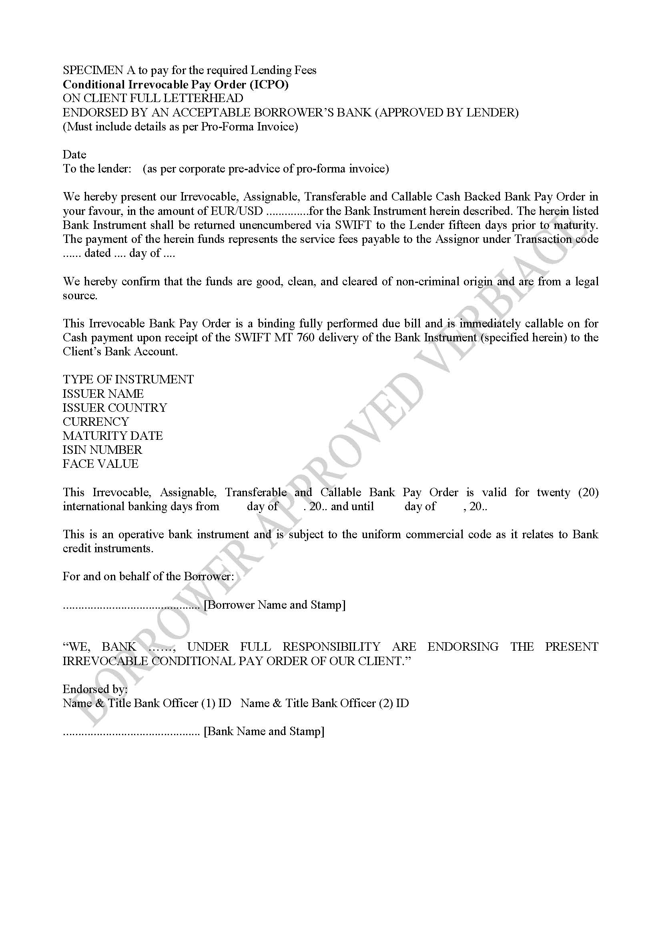
SPECIMEN A to pay for the required Lending Fees

Conditional Irrevocable Pay Order (ICPO)
ON CLIENT FULL LETTERHEAD
ENDORSED BY AN ACCEPTABLE BORROWER’S BANK (APPROVED BY LENDER)
(Must include details as per Pro-Forma Invoice)

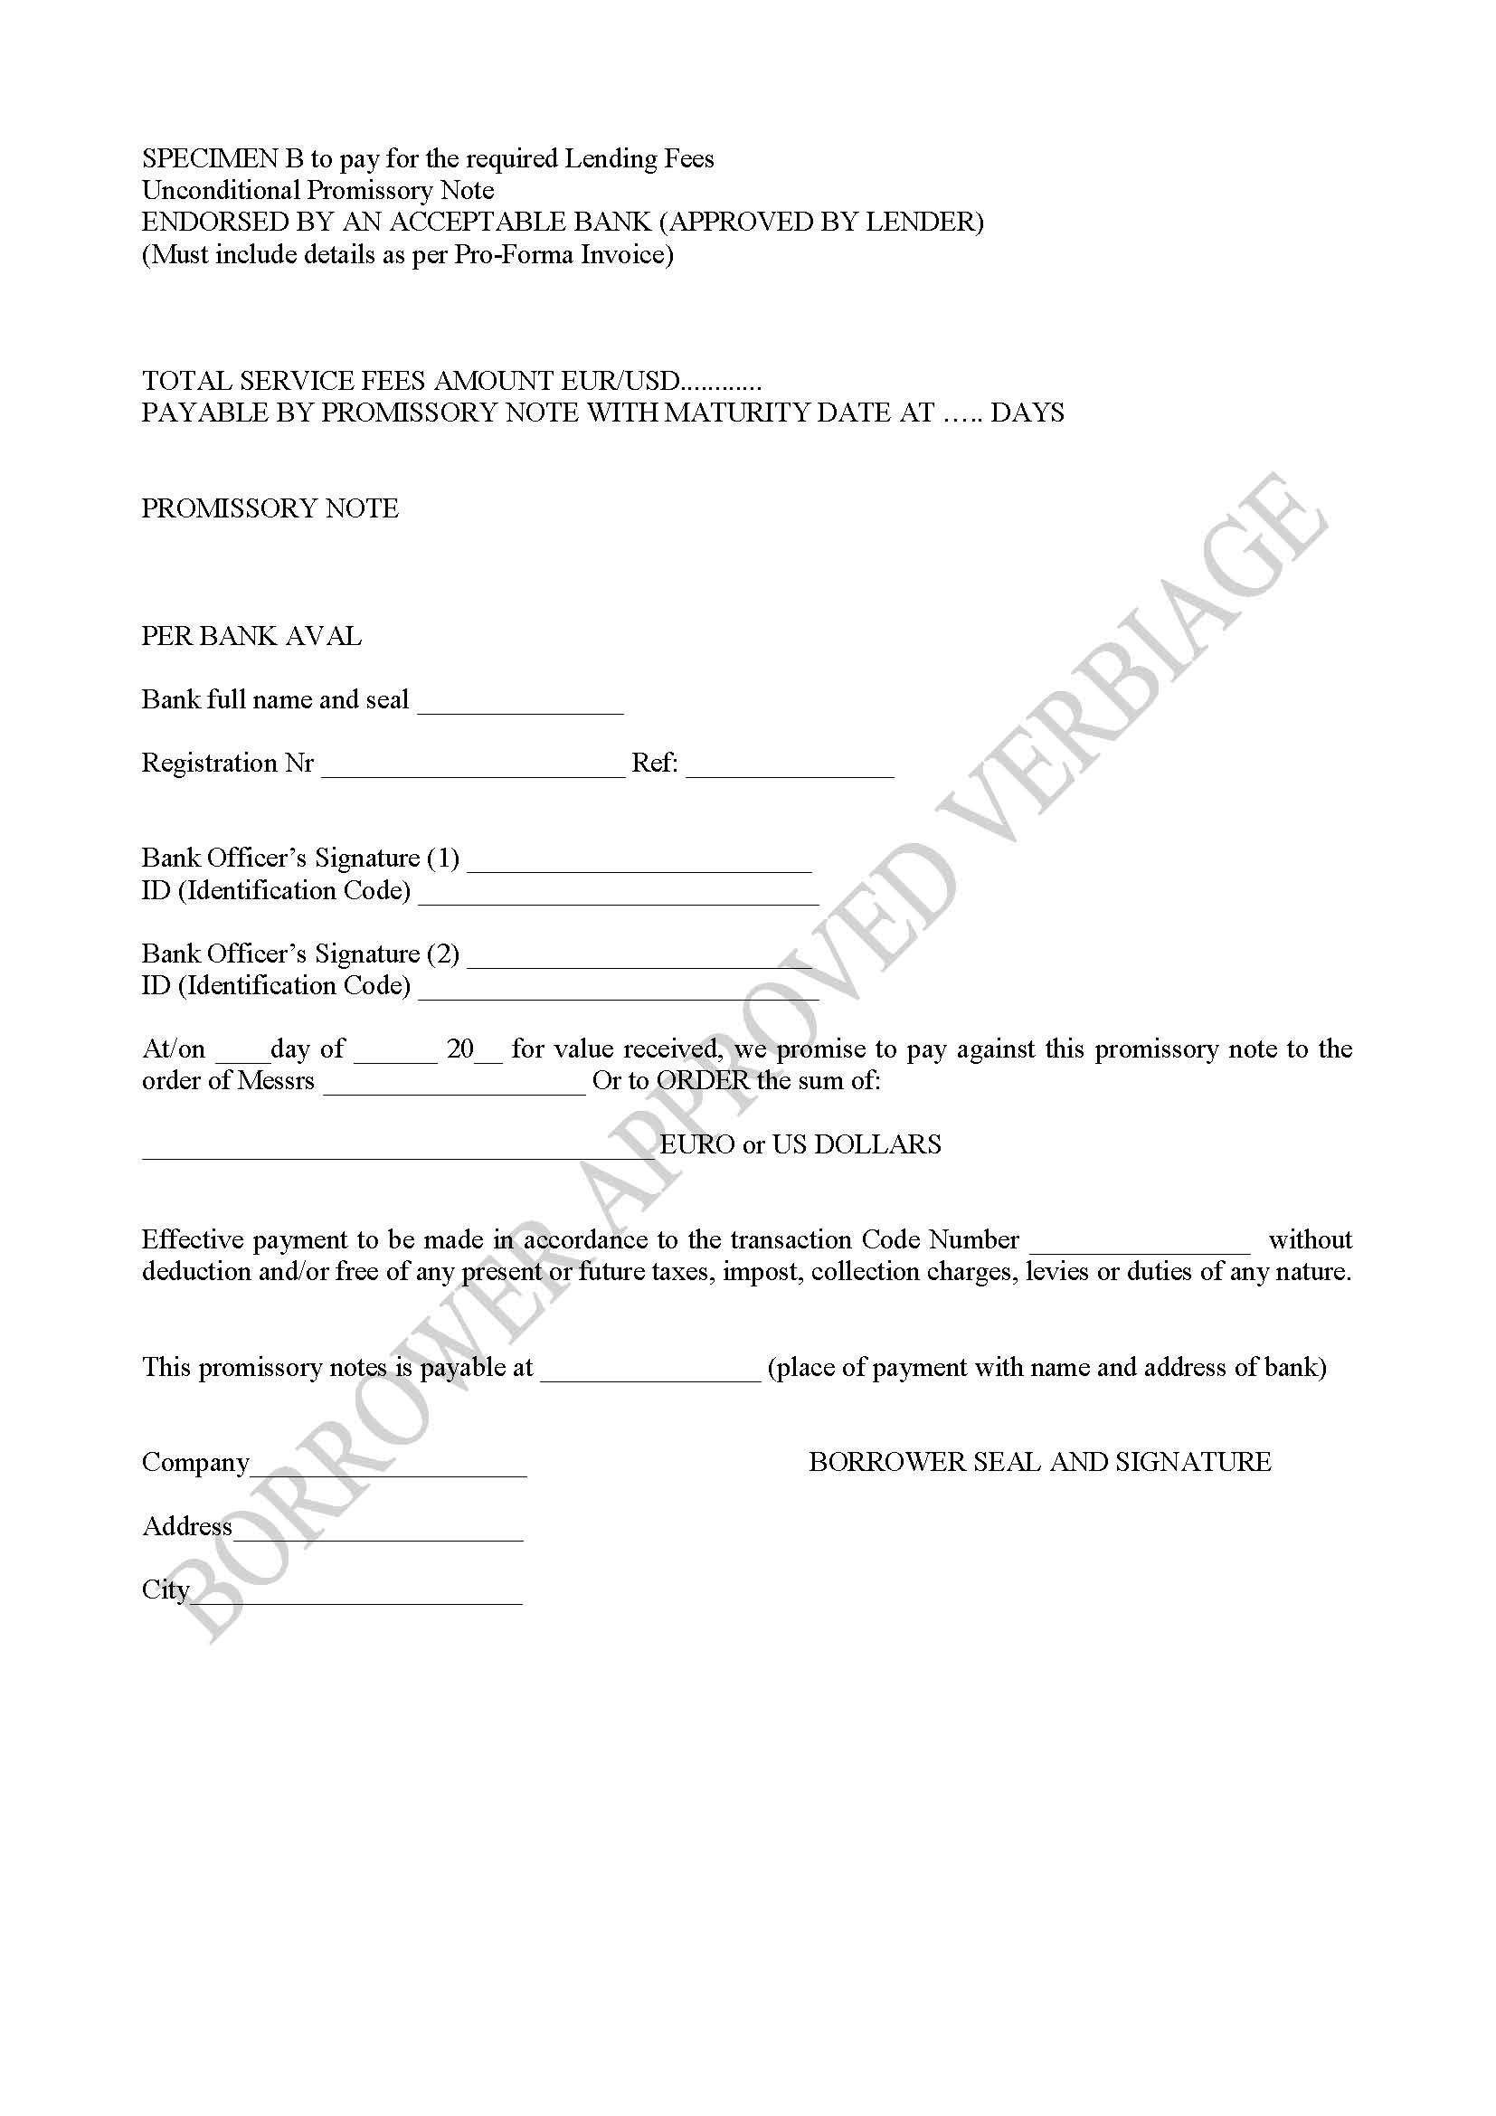
SPECIMEN B to pay for the required Lending Fees

Unconditional Promissory Note
ENDORSED BY AN ACCEPTABLE BANK (APPROVED BY LENDER)
(Must include details as per Pro-Forma Invoice)

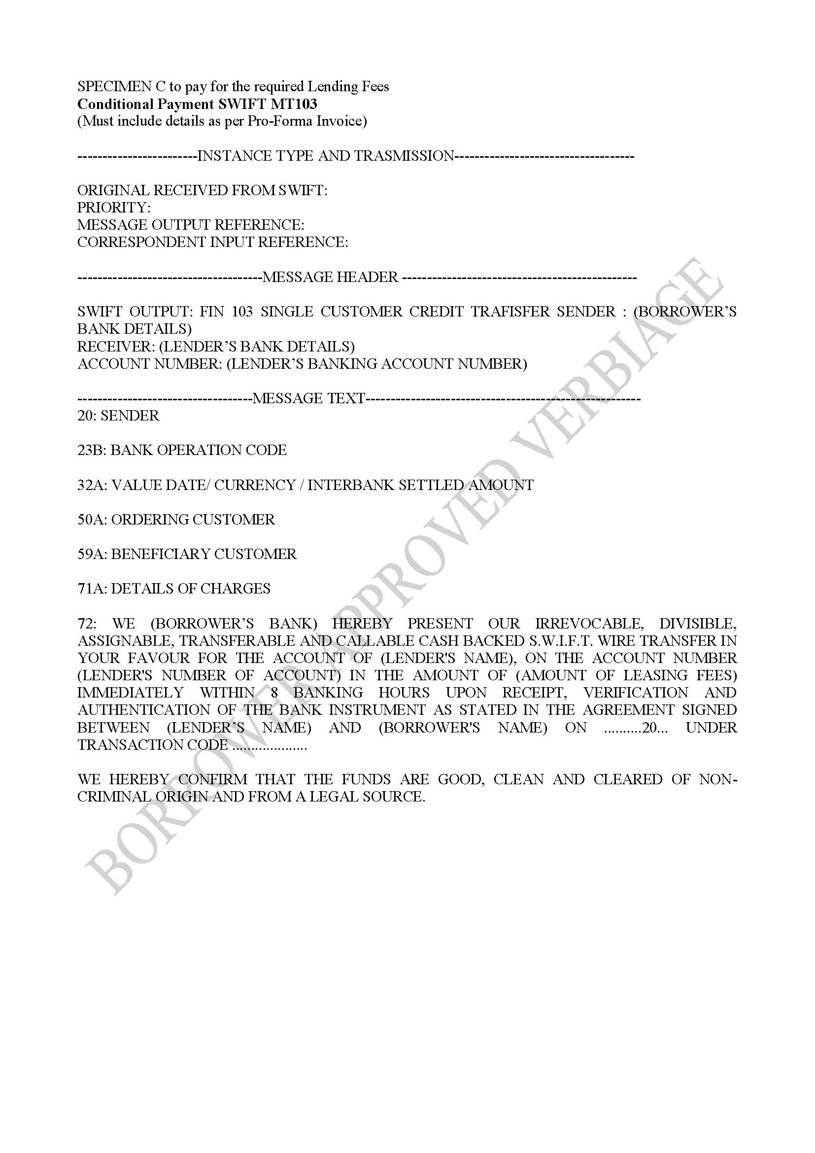
SPECIMEN C to pay for the required Lending Fees

Conditional Payment SWIFT MT103
(Must include details as per Pro-Forma Invoice)

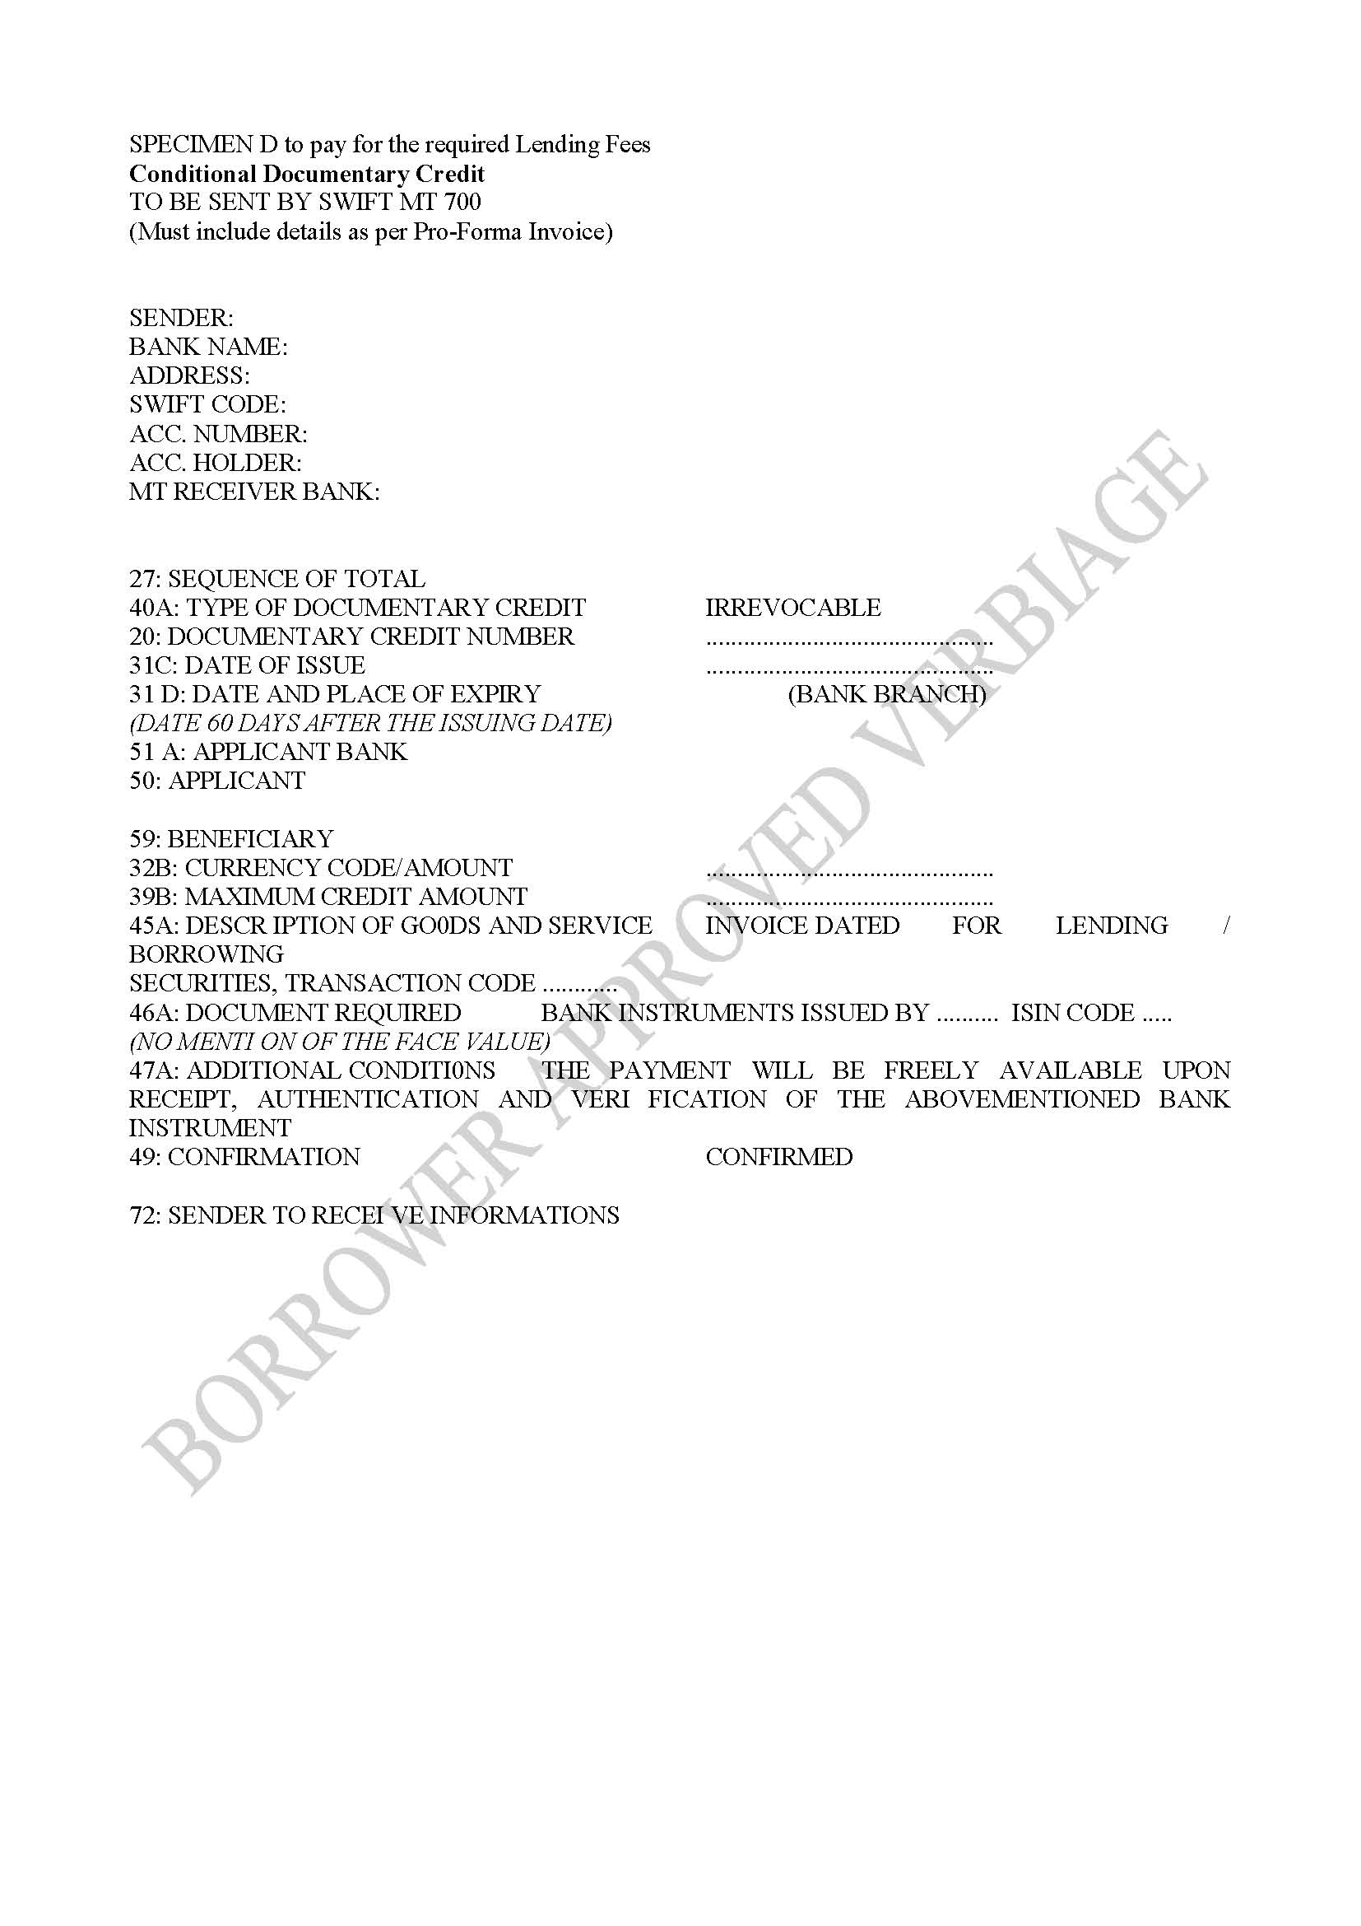
SPECIMEN D to pay for the required Lending Fees

Conditional Documentary Credit
TO BE SENT BY SWIFT MT 700
(Must include details as per Pro-Forma Invoice)

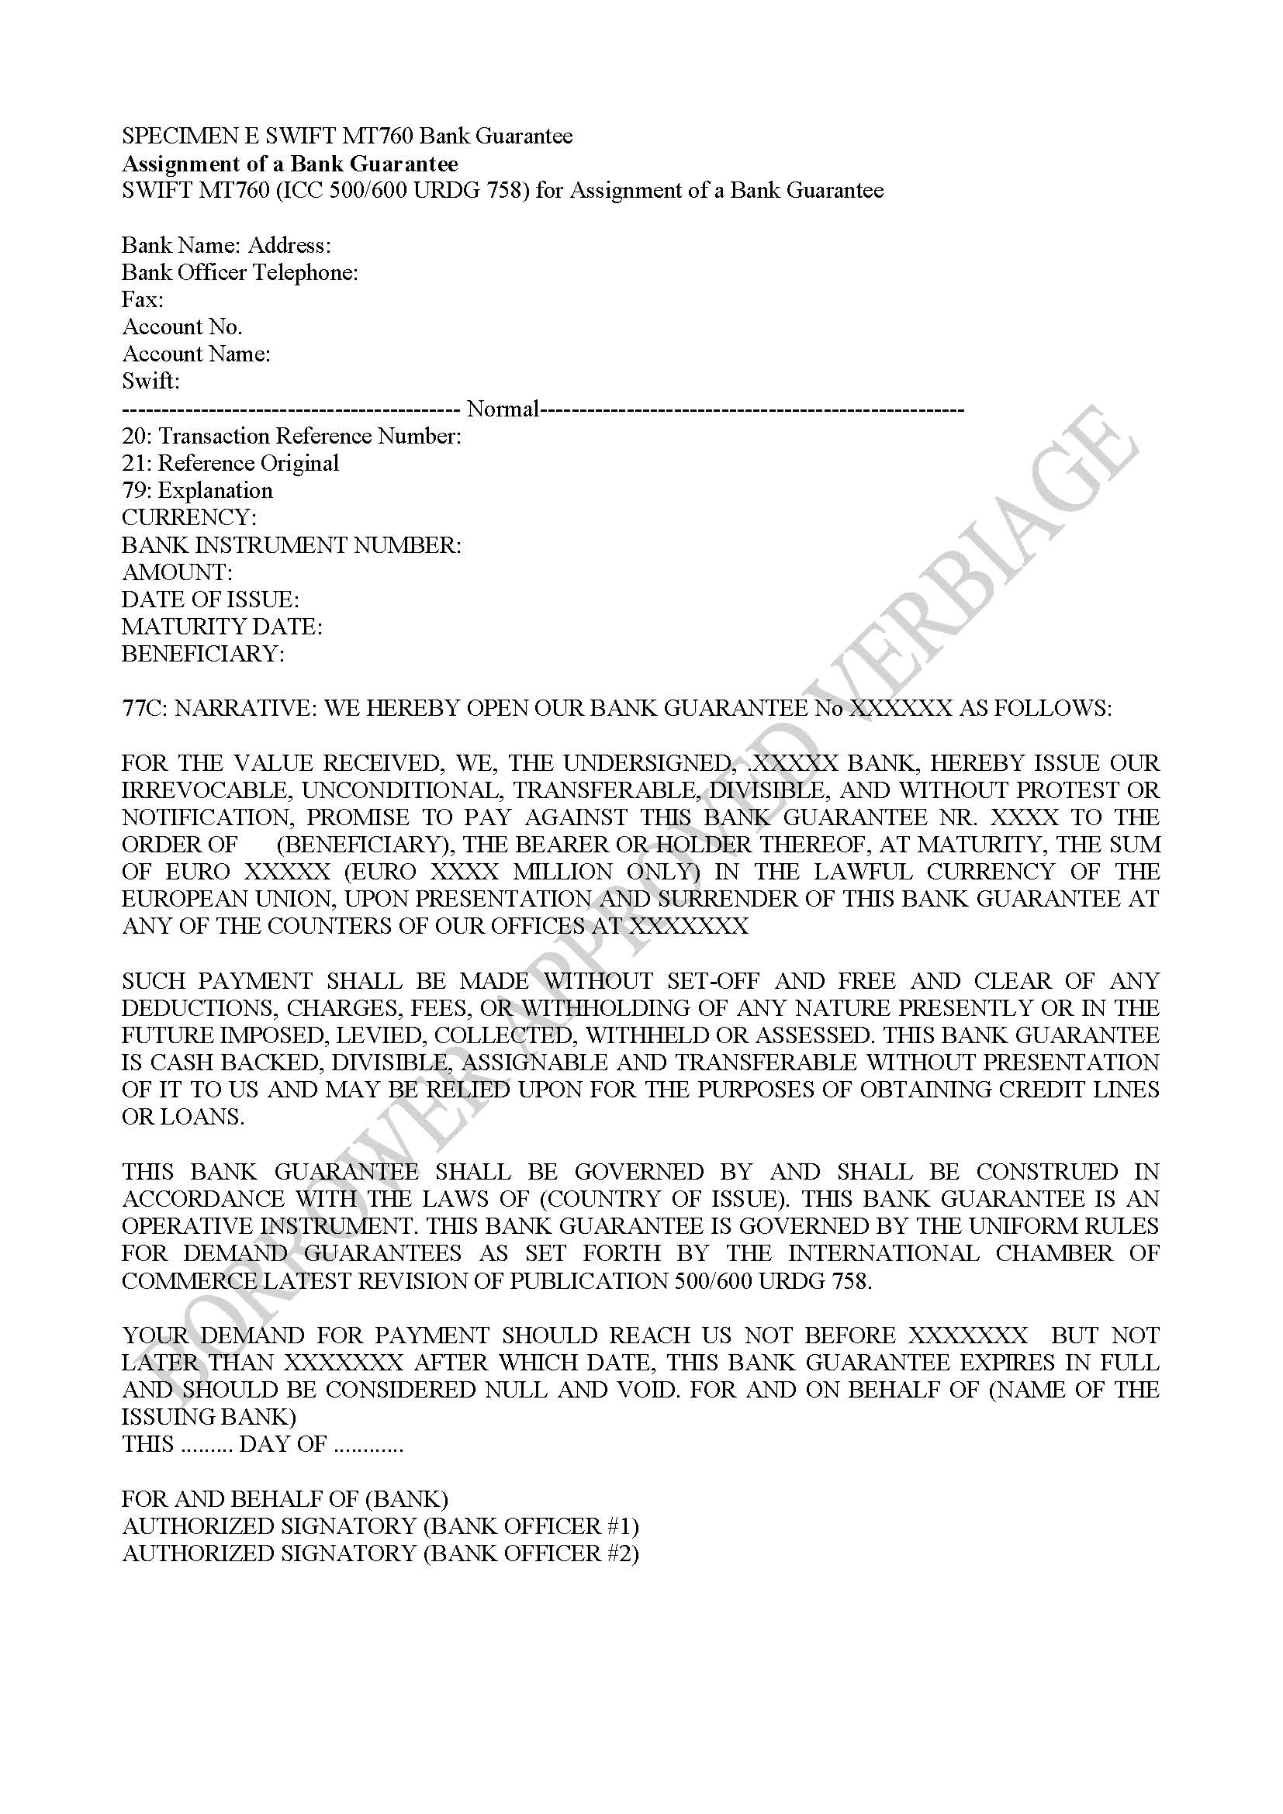
SPECIMEN E SWIFT MT760 Bank Guarantee
Assignment of a Bank Guarantee
SWIFT MT760 (ICC 500/600 URDG 758) for Assignment of a Bank Guarantee

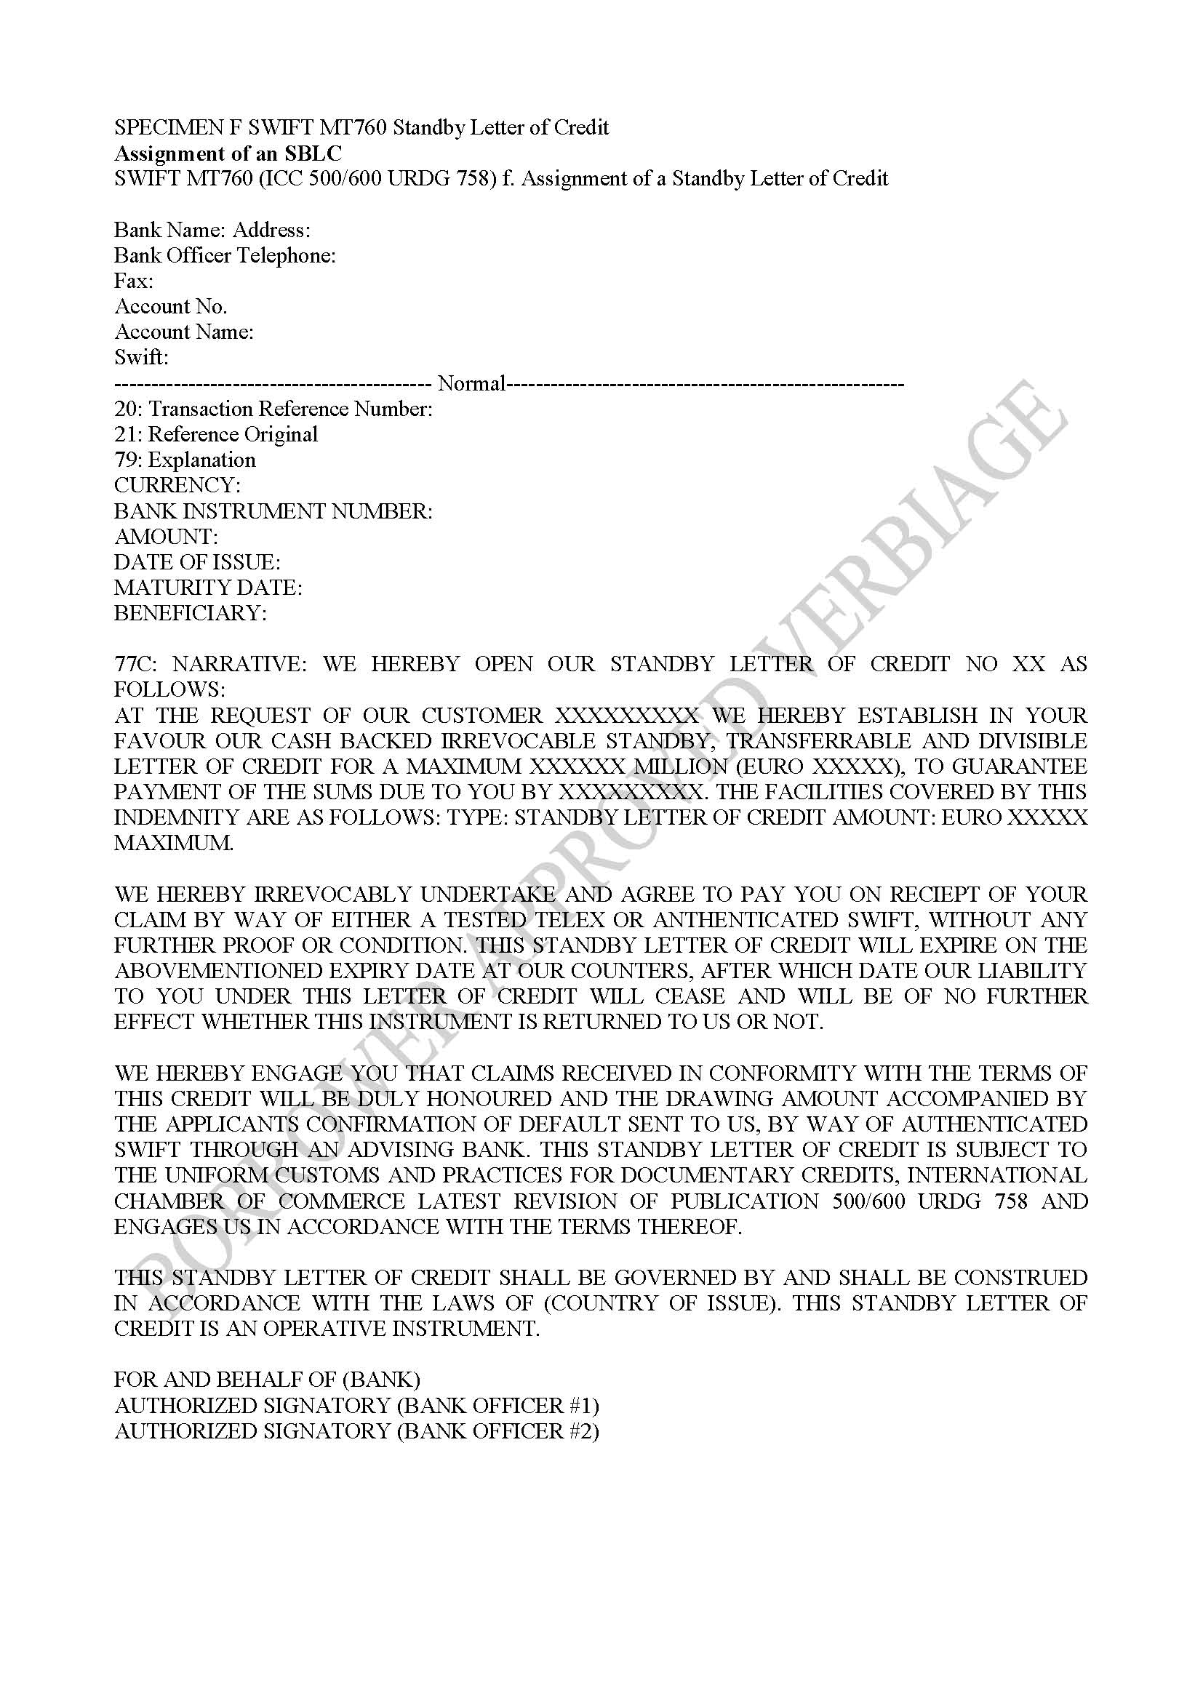
SPECIMEN F SWIFT MT760 Standby Letter of Credit
Assignment of an SBLC
SWIFT MT760 (ICC 500/600 URDG 758) f. Assignment of a Standby Letter of Credit

Variables to enable “auto-complete” this document!
VARIABLES REFERRING TO PROJECT & REQUIREMENTS
[BORROWERCONTRACTNO] | 8 NUMBERS OF YOUR CHOICE
[BORROWERTRANSACTIONCODE] | 10 LETTERS AND/OR NUMBERS OF YOUR CHOICE
[BORROWERSIGNEDDATE00000000] | DATE OF CLIENT SIGNATURE
[DESCRIBTIONPROJECT250CHARACTERS] | PROVIDE A 3 SENTENCE SHORT PROJECT SUMMARY
[EUROFACEVALUEOFINSTRUMENT] | VALUE OF INSTRUMENT
[STATEBGORSBLC] | STATE TYPE OF INSTRUMENT
[PREFERREDPAYMENTMETHODFORLENDINGFEE] | STATE ONE OF THE 4 PAYMENT OPTIONS
VARIABLES REFERRING TO BORROWER COMPANY
[BORROWERCOMPANYNAME] | COMPANY LEGAL NAME
[BORROWERCOMPANYCOMPLETEADDRESS] | STATE THE COMPLETE PHYSICAL ADDRESS HERE
[BORROWERCOMPANYSTREET] | STREET ONLY
[BORROWERCOMPANYCITY] | CITY ONLY
[BORROWERCOMPANYSTATEPROVINCE] | SATE/PROVINCE
[BORROWERCOMPANYZIPPOSTALCODE] | POST/ZIP CODE
[BORROWERCOMPANYCOUNTRY] | COUNTRY
[BORROWERCOMPANYREGNO] | REGISTRATION NO.
[BORROWERCOMPANYDATEINCORPORATION] | INCORPORATION DATE
[REVENUESLASTFISCALYEARINEUROEQUIVALENCE] | You must State last year’s Comp. Revenues in Euro equivalence
VARIABLES REFERRING TO BORROWER PERSONAL DETAILS
[BORROWERFULLNAME] | THE COMPLETE NAME
[BORROWERLASTNAME] | LAST NAME
[BORROWERFIRSTNAME] | FIRST NAME
[BORROWERCOMPLETEADDRESS] | STATE COMPLETE PHYSICAL ADDRESS HERE
[BORROWERDESIGNATION] | JOB TITLE
[BORROWERNATIONALITY] | NATIONALITY
[BORROWERPASSPORTNUMBER] | PASSPORT NUMBER
[PASSPORTCOUNTRYOFISSUE] | ISSUING COUNTRY
[PASSPORTISSUEDWHEN] | ISSUED WHEN
[PASSPORTEXPIREINGWHEN] | EXPIRY WHEN
[BORROWEREMAIL] | EMAIL
[BORROWERPHONENUMBER] | PHONE
[BORROWERWHATSAPPNUMBER] | WHATSAPP
[BORROWERSKYPEADDRESS] | SKYPE
VARIABLES REFERRING TO LEGALS
[LEGALADVISORFULLNAME] | FULL NAME OF YOUR LAWYER
[LEGALFIRMEMAIL] | EMAIL OF YOUR LAWYER
[LEGALFIRMPHONENUMBER] | PHONE NO OF LAWYER
VARIABLES REFERRING TO BORROWER INTERMEDIARY
[INTERMEDIARYCOMMISSIONPERCENT] | COMMISSION AGREED FOR INTERMEDIARY
[INTERMEDIARYFULLNAME] | COMPLETE NAME
[INTERMEDIARYADDRESS] | STREET
[INTERMEDIARYCITY] | CITY
[INTERMEDIARYSTATEPROVINCE] | STATE OR PROVINCE
[INTERMEDIARYZIPPOSTALCODE] | ZIP OR POSTAL CODE
[INTERMEDIARYCOUNTRY] | COUNTRY
[INTERMEDIARYEMAIL] | EMAIL
[INTERMEDIARYBANKNAME] | BANK NAME
[INTERMEDIARYBANKADDRESS] | BANK COMPLETE ADDRESS
[INTERMEDIARYACCOUNTNAME] | ACCOUNT NAME
[INTERMEDIARYACCOUNTNUMBER] | ACCOUNT NUMBER
[INTERMEDIARYSWIFTCODE] | SWIFT CODE
VARIABLES REF. TO BORROWER BANK SENDING MONEY
[BORROWERPAYMENTISSUINGBANKNAME] | BANK NAME
[BORROWERPAYMENTISSUINGBRANCH] | BRANCH
[BORROWERPAYMENTISSUINGADDRESS] | STREET
[BORROWERPAYMENTISSUINGCITY] | CITY
[BORROWERPAYMENTISSUINGSTATEPROVINCE] | STATE OR PROVINCE
[BORROWERPAYMENTISSUINGZIPPOSTALCODE] | ZIP OR POSTAL CODE
[BORROWERPAYMENTISSUINGCOUNTRY] | COUNTRY
[BORROWERPAYMENTISSUINGSWIFTCODE] | SWIFT
[BORROWERPAYMENTISSUINGTELEPHONEBANKOFFICER] | PHONE BANK OFFICER
[BORROWERPAYMENTISSUINGBANKOFFICERNAME] | NAME BANK OFFICER
[BORROWERPAYMENTISSUINGNAMEOFACCOUNT] | NAME OF ACCOUNT
[BORROWERPAYMENTISSUINGSIGNATORYONACCOUNT] | SIGNATORY ON ACCOUNT
[BORROWERPAYMENTISSUINGNUMBEROFACCOUNT] | ACCOUNT NUMBER
VARIABLES REF. TO BANK RECEIVING INSTRUMENT
[BORROWERRECEVINGBANKNAME] | BANK NAME
[BORROWERRECEVINGBANKBRANCH] | BRANCH
[BORROWERRECEVINGBANKADDRESS] | STREET
[BORROWERRECEVINGBANKCITY] | CITY
[BORROWERRECEVINGBANKSTATEPROVINCE] | STATE OR PROVINCE
[BORROWERRECEVINGBANKZIPPOSTALCODE] | ZIP OR POSTAL CODE
[BORROWERRECEVINGBANKCOUNTRY] | COUNTRY
[BORROWERRECEVINGBANKSWIFTCODE] | SWIFT
[BORROWERRECEVINGBANKTELEPHONEBANKOFFICER] | PHONE BANK OFFICER
[BORROWERRECEVINGBANKOFFICERNAME] | NAME BANK OFFICER
[BORROWERRECEVINGBANKNAMEOFACCOUNT] | NAME OF ACCOUNT
[BORROWERRECEVINGBANKSIGNATORYONACCOUNT] | SIGNATORY ON ACCOUNT
[BORROWERRECEVINGBANKNUMBEROFACCOUNT] | ACCOUNT NUMBER

